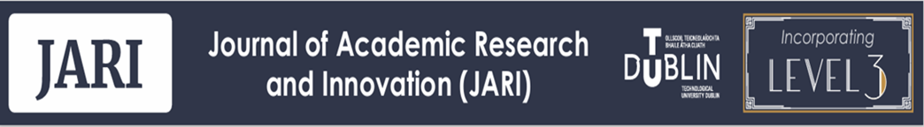

https://arrow.tudublin.ie/jari.ie

Peer Review Process and Report for submissions to JARI

Authors are free to request peer review of original submissions only.
Reviews are invited from two appropriate ‘blind’ reviewers.
Authors are normally advised of peer review decisions as follows:
- Accept as submitted
- Revise and resubmit
- Reject
Submissions which are rejected as peer reviewed publications may be published as non-peer reviewed items, subject to the agreement of authors and editors.
Essentially, peer review of submissions to academic journals is an act of judgement by expert colleagues given in a spirit of collegial respect for the work of others in the academic community. The process cannot be regarded as an exact, numeric science. Peer review criteria for JARI were designed with these principles in mind, as follows:
 | PEER REVIEW CRITERIA | Yes or No or N/A
1 | The subject matter is appropriate for the journal
2 | The submission adds something new to knowledge in the field
3 | The literature review (if used) is current and relevant
4 | The methodology and methods are clear and appropriate
5 | Analysis is clear and appropriate
6 | Data are presented clearly in text, tables and figures
7 | Terminology is consistent and accurate
8 | Conclusions are drawn appropriately
9 | References are accurate and complete
10 | The submission is generally coherent and accessible

Peer reviewer’s comments to author/s
RESULT: Accept as submitted: Revise and resubmit: Reject:

Reviewer: Date:

