General Information for Presenters on DGS 2020 Panels
Dear Speaker,
We are really looking forward to your participation in DGS 2020. You will be part of a session with 2-3 other speakers. The panel sessions are hosted on the TU Dublin Virtual Learning Environment Platform Bongo. In addition to the normal panel chairperson, each panel will also have a moderator who will assist the Chair with the technical operation of the platform.
Presenters are asked to enter the virtual panel session 20 minutes before the session is due to start to ensure they are comfortable with the virtual surroundings and happy that the moderator has uploaded their presentation and they are ready to go. Please ensure your microphone and sound are working on your PC/laptop in advance and use a headset/earphones if available to cut down on reverb.
The links to the panel sessions will be sent by email, on a daily basis, to all those registered for the conference.
When you click on the link provided for the panel session you will see a meeting lobby page below
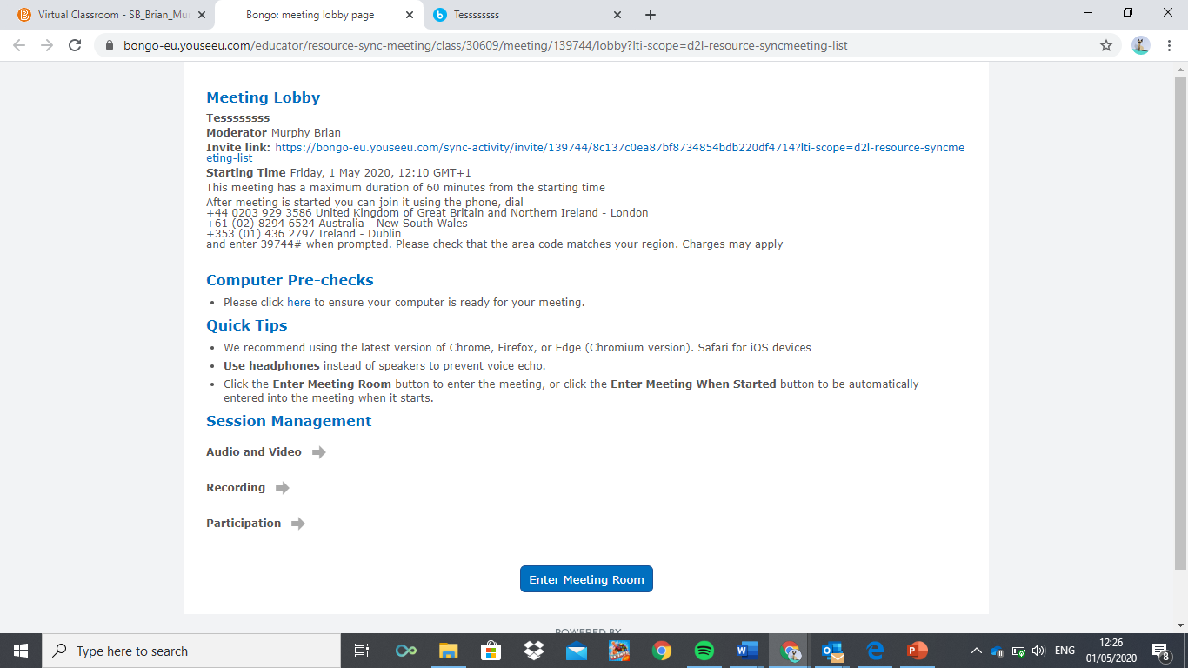
On entering a meeting, the first thing that all participants are asked is ‘How would you like to join the audio?’ Microphone or Listen Only.
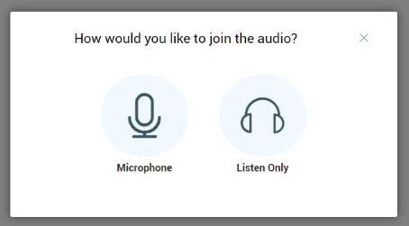
Select Microphone. You will then hear an ‘echo test’ message. If you could hear it, click Yes.
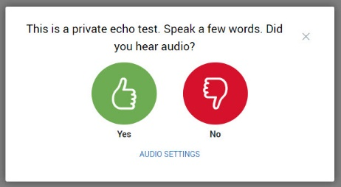
You are now in the meeting room and will be presented with the presentation screen below
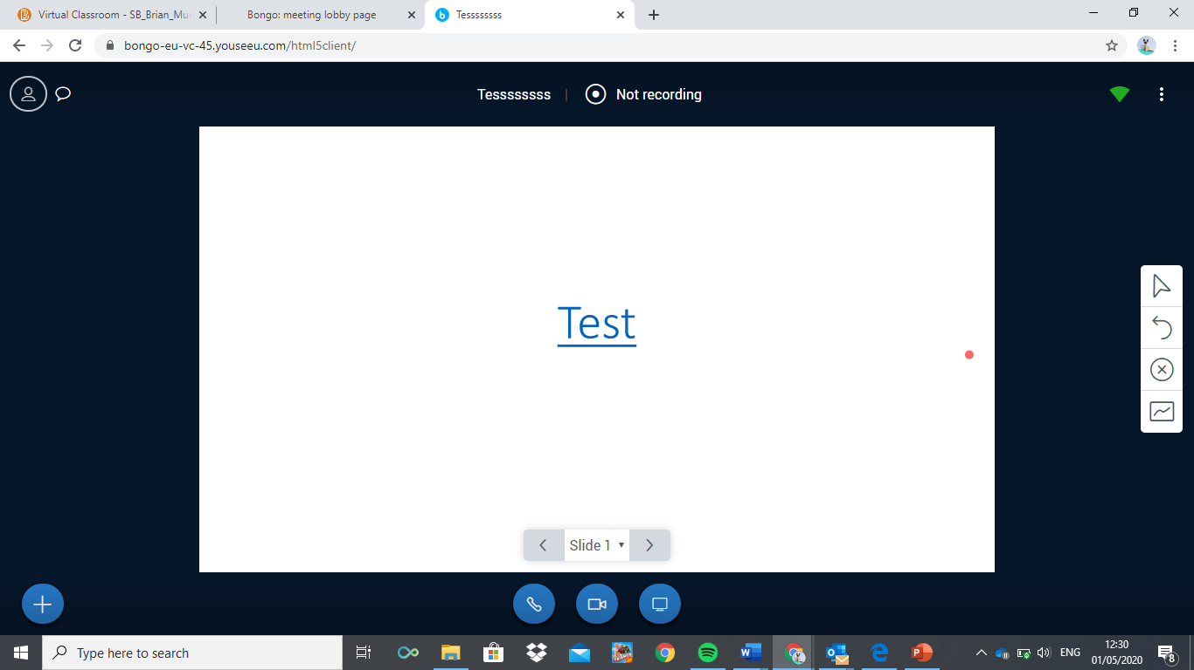
Beneath the screen you will have 3 large blue buttons at the bottom.
The first button turns allows you to join the audio conference
The second button allows you turn on or off your own video camera. We recommend using the microphone only during the presentation to support transmission quality.
The third button is for screen sharing. Please do not use.
Once you join the audio conference you will have another button that controls whether your microphone is on or off.
There are also two buttons on the top left of the screen, and they can be toggled on and off.
The first displays a list of all participants who have entered the panel session. The second displays the chat window and allows all participants to post written comments that all will see. You don’t need to worry about the chat window or questions as the Chair will collect questions to pose verbally to you during Q and A.
Once in the room your name will appear on the participants' list.
As presenter please make yourself known to the chair and the moderator who will check/confirm that the PDF presentations that presenters sent through are uploaded and ready to go. The Chair will introduce you to the audience at the start of the session.
When it’s time for the first presenter to speak the moderator will ensure that they have control of the presentation board allowing them to move their own slides backwards and forwards. If there is more than one presenter: that’s no problem but just decide who will control the slides moving backwards and forward and let the Chair know (only one person can have the control over the slides at a time).
When the first speaker is finished the moderator will upload the next presenter’s slides and move control of the slides to them and repeat this process until all presenters have spoken.
Each presenter will have a strict maximum time of 15 minutes to present.
The panel chair will ensure that presentations are delivered in sequence, on time and will ensure that each presenter is notified when it’s their turn to deliver their presentation.
Once all presentations are delivered there will be a 15-20-minute period of Q & A to cover all presentations. Delegates who want to ask a question will need to type the word “Comment” in the forum chat box and wait to be called for their question. Questions will be fed through the Chair and the moderator will assist in identifying who has a question by monitoring the forum. The Chair can then ask the questioner to speak and the presenter in question can answer accordingly.
Please only activate your microphone when speaking. At all other times keep your microphone switched off.

